Women Who Run With The Wolves
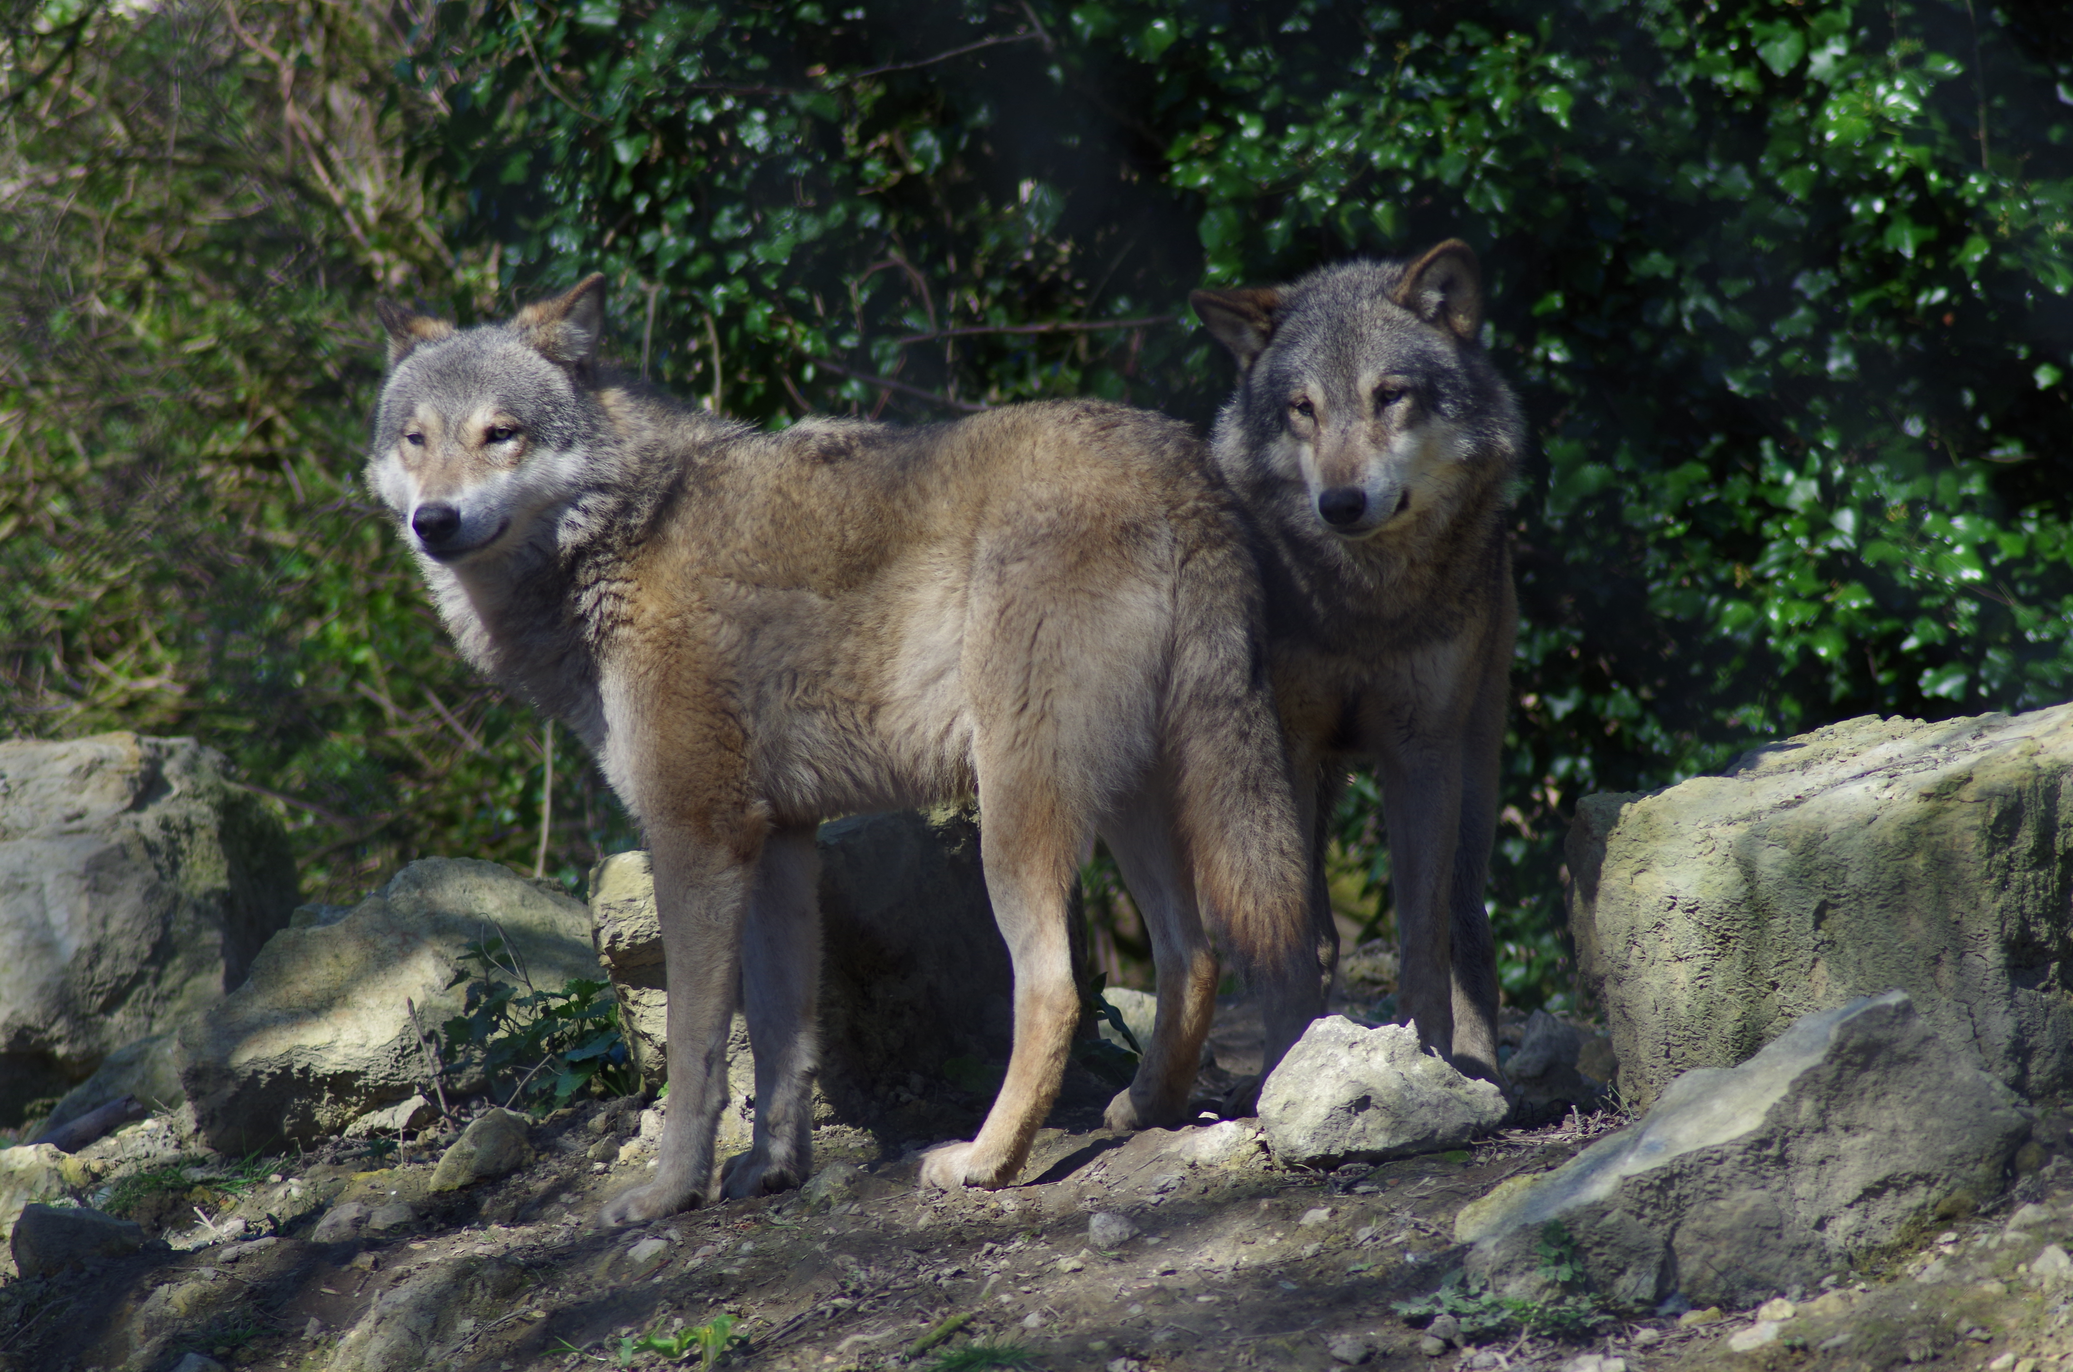
A Samhain Gathering For Women
Exploring Body, Soul, Spirit & The Sacred Feminine. November 2nd 2019

At Samhain, as the wheel turns toward deepest winter join us in circle for a day of myth, story and deep connection to the soul self. Sometimes, as we journey through life, we lose connection with some deep and important aspect of our selves. This day is an opportunity to reconnect with your deep soul Self and with the richness of your embodied creativity.

Our tools for the day will include myth, story and BodySoul Rhythms®. The day will weave together BodySoul Rhythms® and the myth and story work of beloved author Dr. Clarissa Pinkola Estes, whose book “Women Who Run With The Wolves” provides us with maps and storylines for the journey of reconnecting to more of who we really are.

As a part of our time together we will create a Samhain altar; together we will create sacred space. Our days will include myth and story, BodySoul Rhythms®, simple ceremony, movement, stillness, art and creative expression.
The day will be led by Jay Edge. Jay trained with Dr Estes at the Archetypal and Cross-Cultural Studies Institute in Colorado and will be offering some of Dr Estes’ teaching for using the book as a personal guide and companion. Jay is an experienced group leader, has completed the BodySoul Rhythms® Leadership training with the Marion Woodman Foundation and works in private practice as a Psychosynthesis Psychotherapist, Supervisor and Groupwork Facilitator.
We will gather for our Samhain day in a beautiful, old, sacred building in North London.
If you have questions or want to reserve a place call or email me.
The fee for the day is £95. The group is small and places are limited.
0208 292 9328 and 078 8149 2342.
www.journeyofthesoul.co.uk

