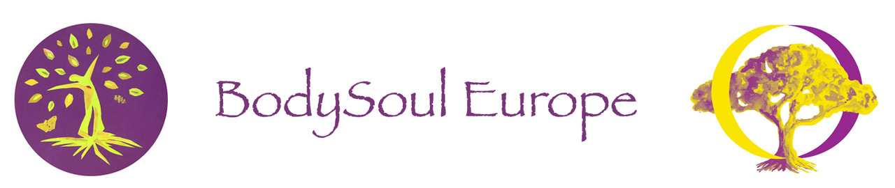
2024 Annual General Meeting
“Spiralling into Presence”
An in-presence Gathering & Celebration

The Ammerdown Centre
Ammerdown Park, Radstock, Somerset BA3 5SW
https://www.ammerdown.org
Friday May 3rd from 4pm to Sunday May 5th 4 pm

Registration Form
PERSONAL DETAILS
NAME
ADDRESS
PHONE NUMBER(S)

EMAIL
EMERGENCY CONTACT

DO YOU HAVE SPECIAL DIETARY NEEDS?  Please select by marking with an X & give details below |  | YES | NO
VEGETARIAN
VEGAN
GLUTEN FREE
DAIRY FREE
OTHER | Please explain (including specific allergies if any).
Ammerdown provides vegetarian, vegan and gluten-free options at no extra charge.
There is an additional charge of £10 for the weekend for other special diets: please add it to your room fee

WEEK-END FEE
Single Room: £ 275
Double Shared Room: £ 255
Includes full room & board from the start to the end of the gathering, art materials and meeting room hire.

Email your online application form to Clare at agmbodysouleurope@gmail.com and make your payment by March 21st.
(Possibility to make a £ 100 deposit first, with the balance due by April 21st)

ACCOMMODATION TYPE

WHICH ROOM TYPE WOULD YOU LIKE TO BOOK?  Please select by marking with an X: | SINGLE | DOUBLE SHARED
If Double shared, with whom do you wish to share?

ONLINE PAYMENT DETAILS
Via Bank Transfer:
Bank name/address: Lloyds Bank / Cattle Market Cambridge; 78-80 Cherry Hinton Road; CG1 7BH Cambridge UK
Name of Account Holder: BodySoul Europe.
SORT CODE: 30-91-74 ACCOUNT NUMBER: 02568540

BIC: LOYDGB21206
IBAN: GB79LOYD30917402568540

Please reference your online payment using your name followed by: /AGM2024 (e.g. Lampe/AGM2024)
(N. B. For participants from outside the UK, all bank transfer fees are payable by payee and not by BodySoul Europe)

Via Paypal:
Simply click on the following link: https://www.paypal.com/paypalme/bodysouleurope
In this case, the amount to be paid would need to include the Paypal 2.9% fee, so we would appreciate if you could pay:
- £282.98 for a Single Room
- £262.40 for a Double Room

In the case of Other Special diets (ex: allergies), please add £ 10 to your selected week-end fee.

Note that a limited number of bursaries are available upon request.
FEE PAYABLE
I am sending a bank transfer for GB £: |  | I am sending a Paypal transfer for GB £:

CONFIRMATION OF REGISTRATION
An email confirming your registration will be sent upon reception of payment.

SIGNED: | DATE:

(Electronic Signature honoured)

